**Docker on centos7**

**Step 1 : switch to root user**

sudo su

**Step 2 : update repo list**

yum update -y

**Step 3 : run ip a and verify the output**

**Before installing docker**

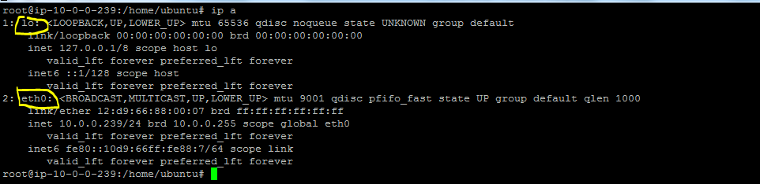

**Step 4 : Install docker**

yum install wget -y

wget -qO- https://get.docker.com/ | sh

**Step 5 : verify docker installation ( changes on ur host)**

docker version

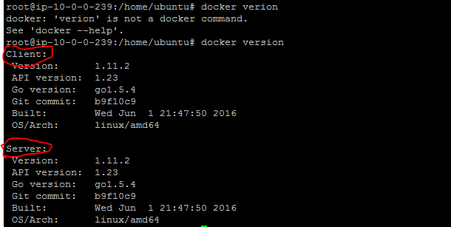

**Step 6 : Start docker services and verify docker bridge is created ( changes on ur host)**

service docker start

ip a

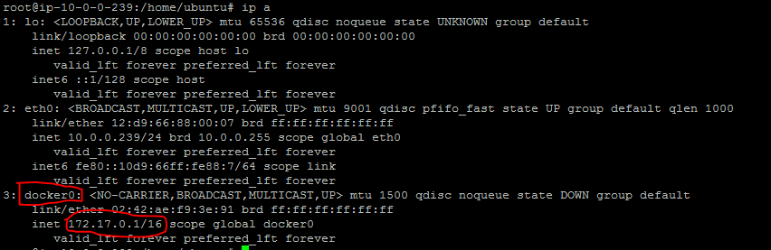

**Step 7 : List containers**

docker ps -a



**Step 8 : List images**

docker images



**Step 8 : Obtain details information about your host**

docker info